BRAD BOWMAN FIELD AT PATRIOT PARK
10-2019
Field Use Guidelines

- The field is primarily designed for children and adults with specials needs. Programs for participants with special needs, such as KLL Challenger Baseball, KSC TOPSoccer or Special Olympics have priority use.
- Kearney Park & Recreation Programs, such as Start Smart Baseball/Softball/Soccer, are second on the list of priority use.
- When not being used for priority programs, the field can be used by the general public for drop-in play, such as whiffleball or kickball games. The field may also be used, on a first-come first-served basis, by Kearney youth sport association teams (10 & under preferred) for modified practices when the regular grass fields are not available. However, the following rules which are posted at the field, need followed:
- Hitting pitched baseballs or softballs is not allowed on this field with the exception of special programs which have been pre-approved. Whiffleballs or foam balls are acceptable.
- Soft-soled shoes only. No cleats. Please make sure shoes are free of mud and gum.
- Other than water, sport drinks or other liquids are not allowed on the turf.
- Food, sunflower seeds, gum, and tobacco products are not allowed on the turf.
- Pets are not allowed on the turf.
- Equipment and activities must be appropriate for a field of this size.
- Please throw away all trash in the receptacles and take your belongings with you.

If questions, please contact
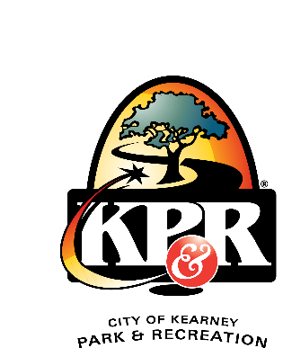
the City of Kearney Park & Recreation Department
at 237-4644.
